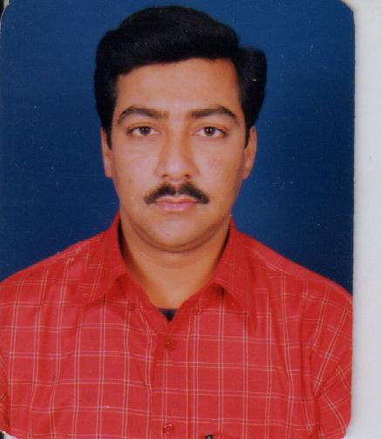
Present Address:
L-704, Hibird, Niho Scottish Garden, Ahinsa Khand 2, Indirapuram,
Ghaziabad (U.P)

Permanent Address:
17, Suraj Nagar,
Suraj Nagar,Near S.B.I., Jwalapur
Haridwar (Uttarakhand),
Mobile No. : 09897370460
Email: sandeepkhanna2012@yahoo.com

Career Objective : | I wish to become part of an esteemed Organization, where career growth prospects are high and working in good environment to increase knowledge.

Professional Qualifications :

- "O" level computer course from DOEACC in April’1997.
- “A” level computer course from DOEACC in Sept’2000.
Educational Qualification :

- M.Com from D.A.V. (P.G) College, Dehradun in Sep’1996
- B.Com from D.A.V. (P.G) College, Dehradun in Aug’1994
- Intermediate from U. P. Board Allahabad in 1990.
- High School from U. P. Board Allahabad in 1988.

Professional Experience:

I would like to introduce myself as a motivated energetic youth with refined skills & having approx. 16 years experience details are as follows:

- M/s Link Enterprises, Jwalapur, Haridwar (A Road Construction Company)

Period | : 14 Years (April ’2001 to December’ 2014)
Role | : Executive Assistant To Managing Director & Directors (Technical & Operation)
Areas of Exposure
- Recruiting, Training & Deployment of Employees.
- General Administration
- Travel Management
- Documentation
- Event & Seminar Management
Job Description:

- Providing executive support in a one-on-one working relationship.
- Also serves as a liaison to the board of directors and senior management teams Organizes and
Coordinates executive outreach and external relations efforts; and oversees special projects, with
strong written and verbal communication, administrative, and organizational skills, and the
ability to maintain a realistic balance among multiple priorities.
- The ability to work independently on projects, from conception to completion, and must be able to work under pressure at times to handle a wide variety of activities and confidential matters with discretion.

Roles & Responsibilities:

- Extensive Calendar Management.
- Provide high level secretarial and administrative support to the CEO.
- Manage schedules and itineraries. Arrange and coordinate meetings and functions. Draw up and
distribute minutes of meetings.
- Prepare correspondence, documents, presentations. Conduct research, organize data, generate
Reports.
- Provides assistance in the understanding and interpretation of company policies & SOPs and
ensures that office operations are in compliance with policy provisions and standards.
- Establish work priorities, delegate work to office support staff, and ensure deadlines are
met and procedures are followed.

- M/s Forace Polymers Pvt. Ltd., 10th Km Stone,Delhi- Haridwar Road, Bahadrabad
(Chemical Industry)

Period | : 1 Year & 1 Month (December 04 ’2014 to January 30 ’ 2016)
Role | : Executive Assistant to Managing Director & Directors (Technical & Operations)
Task Assigned
- To arrange for writing minutes of the Chairman’s meeting and take follow-up action on the proceedings of the committee of management.
- Supervision & Controlling of all the staff under control.
- Maintain an effective oral & written communication process between executive administrators and their staff.
- Ensuring safety & security of office records and properties etc.
- Cooperation & achievements of accompany employees to achieve goals toward progressively increasing company sales.
- Identifies prospectively customers that complement current parameters and formulates plans on how to best interact with prospects matching current customers characteristics.
- To provide leadership in formulating the advertising, branding, direct marketing, sponsorship, public relations, sales promotion & online marketing functions of a company.
- Interact with customers & prospects on a personal level via the telephone, trade shows & other interpersonal Business Communication media.
- To keep senior management aware of retention of customers and acquisition of new customers efforts.
- To cover standard reports showing numbers of current customers & their details along with information on bringing prospects into the customer’s category for senior management make time business decisions through Power Point Presentations.

Other Responsibilities | - Making international & domestic travel arrangements including agenda management, invite  - Letters, obtaining forex, Cab arrangements, hotel reservations etc., and managing travel.  - Reimbursements and settlement of the same after the travel within the timelines.  - Maintaining business calendar of events and daily schedule and provide relevant materials for meetings and appointments.  - Maintaining efficient operation of all office equipment by performing minor service duties and arranging for routine and necessary maintenance as needed.

Skill Set:
Operating System : Windows Xp, Windows 7 & Windows 8.
RDBMS : Ms-Access, FoxPro.
Tools : Ms-Office 2003, 2007 & 2010 for Windows Xp, 7 or Higher & Tally.
Typing : English (60 wpm) & Hindi 25 (wpm)

PERSONAL SKILLS
- Comprehensive problem solving abilities and willingness to learn.
- Goal oriented, highly focused & if motivated who excel in high pressure situation.
- Hard working ability in every condition and any situation.
- Maintain punctuality in every step of my life.

Reason to Join
the Company: I want a Stable, Suitable and Challenging Job.

Personal Profile :

Father’s Name : Shri R.K. Khanna
Date of Birth : 31st March 1973

Sex : Male
Marital Status : Single
Language Known : Hindi & English.

I hereby declare the information given above is true up to the best of my knowledge.

( Sandeep Khanna )
Place : Haridwar (Uttarakhand)
Date : 09.07.2018

